**Financial Literacy Program Targeting Analysis**

**Prepared by: Abdelrahman Harb**

**Prepared for: Rafi Ptashny, Chief Data Analyst**

**Date: 19 jan 2025**

1. **Executive Summary**

This report analyzes survey data to identify key demographics in need of financial literacy programs.

²

1. **Project Background and Objective**

InvestInMinds Foundation aims to improve financial literacy in low-income school districts. This project analyzes survey data to identify specific demographic groups most in need of targeted financial literacy programs. The findings will inform the foundation's strategic initiatives and maximize program impact.

1. **Data and Methodology**
2. **Data Source:** Survey data provided by InvestInMindsFoundation.
3. **Data Cleaning:** Data cleaning involved firstly dealing with missed values which spanned four of the five columns.

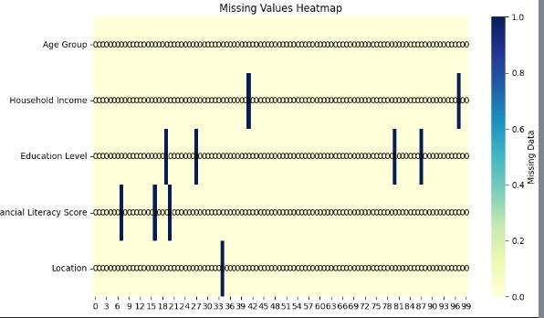

I dealt with the numerical column ‘Financial Literacy Score’ using advanced method ‘KNN’ which fill the missing values with the nearest neighbours ‘with taking every feature in consideration ‘ that's by far more accurate than the naive approach of just filling it with median value.

Then I had to deal with the missing categorical values..

I had two approaches firstly to replace each missing value with the mode ‘the top frequent value ‘ that would work for a dataset with large numbers but here it will produce significant bias, so i chose to replace it with a constant value ‘MISSING’ to test the affection of that phenomena.

I did the whole analysis and drew a conclusion, then I took another approach by deleting every row with a missing value and I found that exact 10% of the data had been lost but the final conclusion was still the same.

Which proved the fact that the data almost perfectly randomly selected ‘or at least looks like that ‘.

I so relied on the version with the ‘MISSING’ constant values and left a graphs and figures at the end of the project notebook to prove my claim.

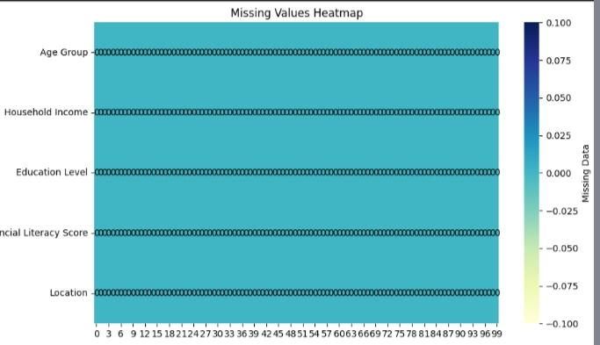

Then i moved to removing outliers, i tested three approaches and finally chose one method of them and applied it to the data.

We now are free of ..

**Missing values & outliers.**

1. **Data Analysis**:

I included on the project notebook tables and graphs about ,

Calculated average financial literacy scores for each demographic group.

Compared scores across different groups to identify statistically significant differences.

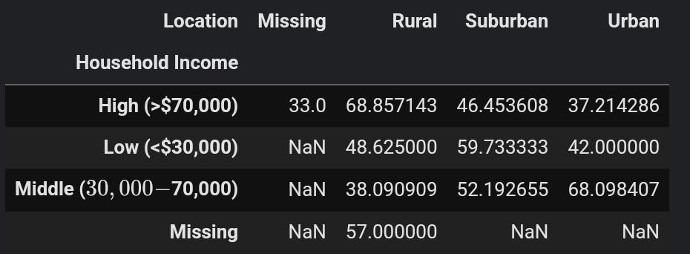

**4. Findings:**

1. **Overall Financial Literacy:**

the distribution are spreading across a wide range ‘there are a relatively large number of each bin or ground of the Financial Literacy Score’ that makes nearly ‘but not accurately ‘ uniform or at least if the number of bins was small’.

That made also the affection of outliers ‘even before removing them relatively low’

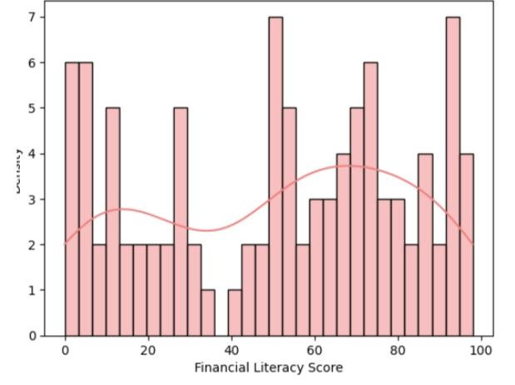

1. **Financial Literacy by Age Group:**

The smallest group in financial literacy scale is the people from 45/54.

Then the youths 18/24

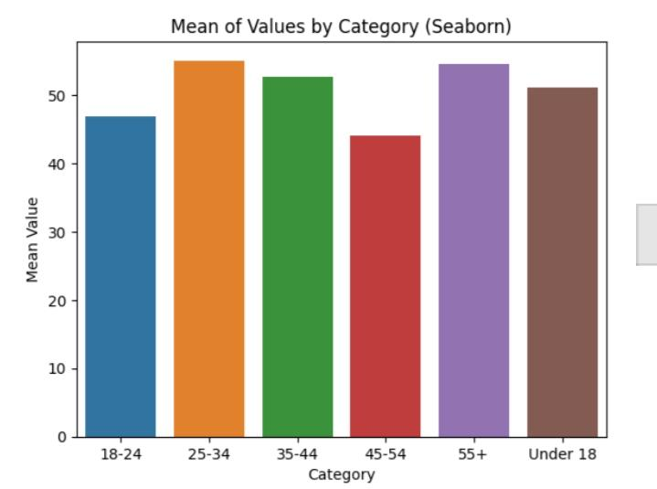

1. **Financial Literacy by Household Income:**

I found that the worst scale was for the HIGH INCOME i supposed at first that's was because of missing values but after repeating it with exclusion of them i found the same results.

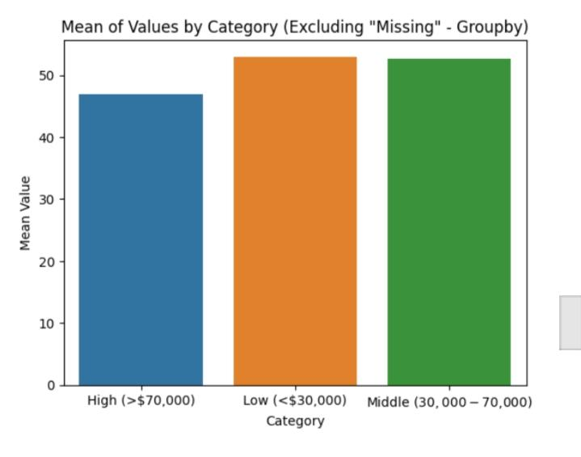

1. **Financial Literacy by Education Level:**

People with Bachelor's degree ‘in general found to be at the bottom, but when merging another factors i found that this result is fault.

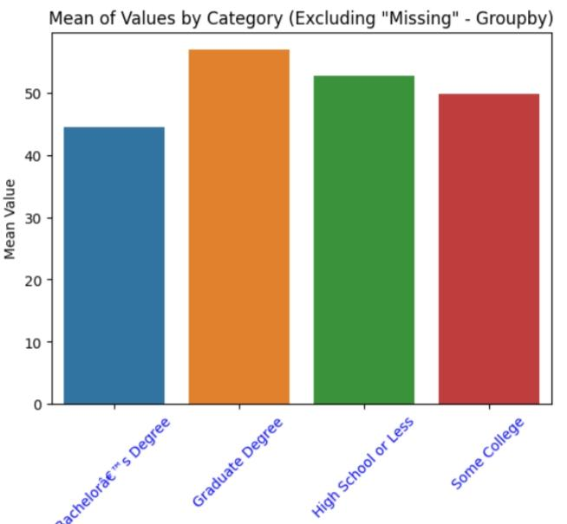

1. **Financial Literacy by Location:**

Urban is the worst in the scale, but again that's just a rush conclusion.

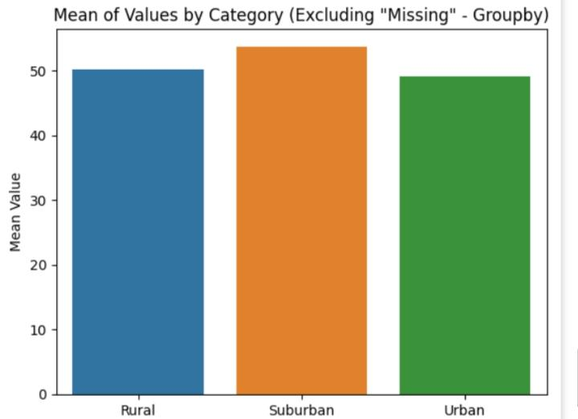

1. **Combined Analysis:**

With considering all factors i found that People which is at those combinations,

(Rural, low income , bachelor's degree , under 18)

Are the worst case ones.

Then the second combination, (Rural, middle income, bachelor's degree, under 18),

Then ( Rural, middle income, college, under 18)

Then (suburban , low income, graduat degree , from 18/24)

The demonstration table and graphics are included in project notebook as a reference.

**5. Recommendations:**

1. **For the Under 18 Groups (Rural, Low/Middle Income, Bachelor's/Some College):** Focus on Foundational Skills: These individuals are likely still in high school or just starting college.

The focus should be on building a strong foundation in personal finance.

**Recommendation 1:** Partner with Rural Schools: Collaborate with high schools and community colleges in rural areas to integrate financial literacy into the curriculum. This could be through workshops, guest lectures, or even incorporating modules into existing courses like math or social studies.

**Recommendation2:** Age-Appropriate Content: Develop engaging, age-appropriate content that resonates with teenagers. This could include using gamification, interactive online tools, or real-life scenarios relevant to their experiences (e.g., budgeting for social activities, understanding part-time job paychecks, planning for college expenses).

**Recommendation 3:** Emphasize Long-Term Planning: While immediate needs are important, introduce the concept of long-term financial planning, including saving for college, understanding debt, and the basics of investing.

**Recommendation 4:** Utilize Technology and Online Resources: Given the rural location, online resources and webinars could be particularly effective in reaching this demographic. Create easily accessible online modules and interactive tools.

**Recommendation 5:** Peer-to-Peer Mentorship: Pair older students or young professionals with younger students to provide mentorship and guidance on financial matters.

1. **Specific Recommendations for the "Bachelor's Degree" Subgroup (Under 18):**

**Address Misconceptions:** The fact that these individuals are pursuing a bachelor's degree but still exhibit low financial literacy suggests a potential disconnect between academic pursuits and practical financial knowledge. Address common misconceptions about debt, student loans, and the value of different degrees in terms of career prospects and earning potential.

1. **For the 18-24 Group (Suburban, Low Income, Graduate Degree):**

Focus on Practical Application and Debt Management: This group is likely navigating early adulthood, including managing student loan debt, starting careers, and potentially starting families.

**Recommendation 1:** Workshops on Debt Management: Offer workshops specifically focused on managing student loans, credit card debt, and other forms of debt. Provide tools and resources for creating budgets and repayment plans.

**Recommendation 2:** Career and Financial Planning Integration: Connect financial literacy with career planning. Help them understand the financial implications of different career paths, salary negotiation, and benefits packages.

**Recommendation 3:** Focus on Investing and Saving: Introduce basic investment concepts and strategies for building long-term wealth. Emphasize the importance of saving and budgeting, especially given their low-income status.

**Recommendation 4:** Targeted Outreach to Graduate Programs: Partner with graduate programs in suburban areas to offer workshops and resources specifically tailored to the financial challenges faced by graduate students.

1. **Overarching Recommendations:**
2. **Tailored Messaging:** Develop targeted messaging that speaks to the specific needs and concerns of each demographic group.
3. **Measure and Evaluate:**

Track the effectiveness of programs and make adjustments as needed. Collect data on program participation, changes in financial knowledge, and behavioral changes.

1. **Community Partnerships:**

Collaborate with local community organizations, libraries, and other institutions in rural and suburban areas to expand reach and access to programs.

1. **Financial Aid Awareness:**

Emphasize awareness of available financial aid, scholarships, and grants to reduce the financial burden on low-income individuals pursuing higher education.

**Abdelrahman Harb**

[3bd0.g0m3aa@gmail.com](mailto:3bd0.g0m3aa@gmail.com)

(+20)01017529210